Cisco Webex Events

Install / Join a Meeting

- Click the event link in your email invitation.
- Once on the Event Information page, enter your name, email address, and the event password (the password may already be entered as shown in the image below. If so, you can go to step 3).
- Select Join Now.
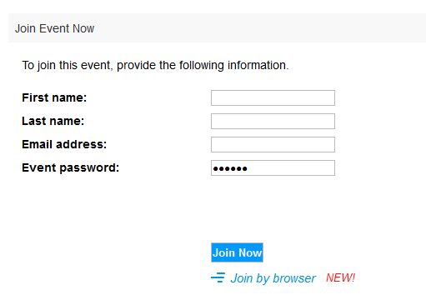

Please note: Avoid using the “Join by browser” option. We strongly recommend that you use the Webex desktop application as this will provide you with access to all of the features Webex Events has to offer.

Download Webex

The following section provides instructions on how to download Webex when using the following browsers:
- Google Chrome
- Mozilla Firefox
- Safari
Google Chrome
Click on “Add Webex to Chrome” | 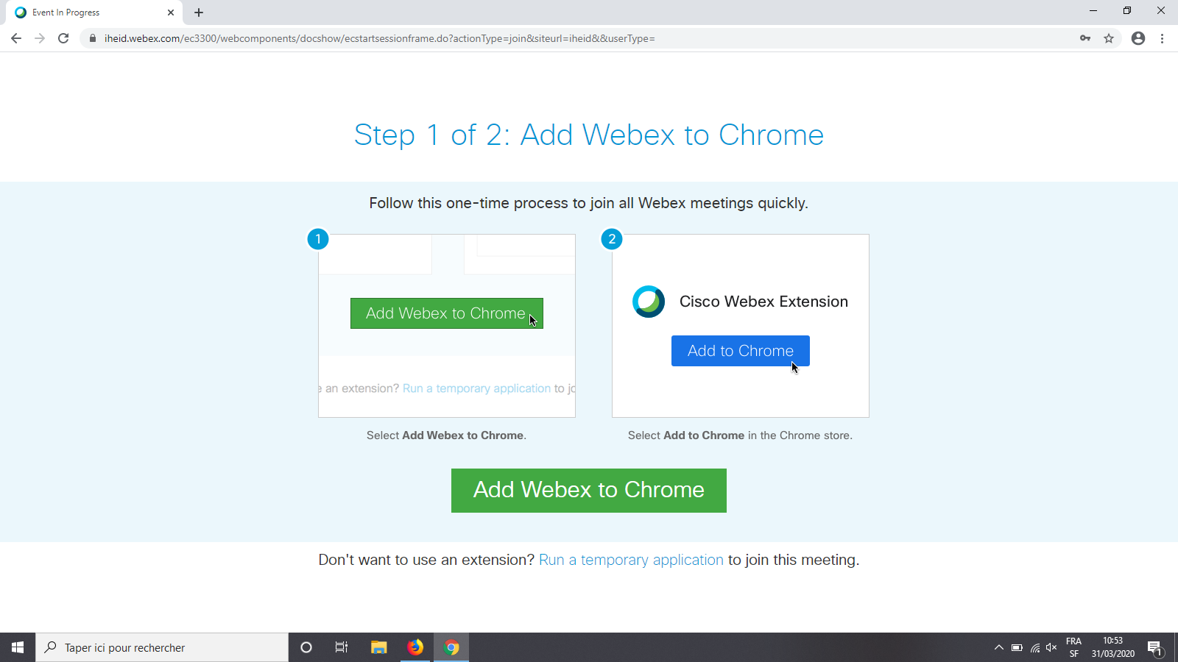

A new tab will open,  Click on “Add to Chrome” | 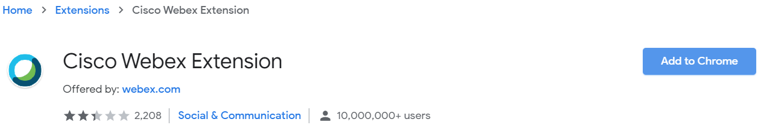
Click on “Add extension” | 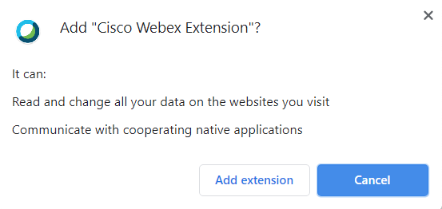
You will be automatically directed to the following tab which is the final step.  Open “Cisco_WebEx_Add-on.exe” (or .dmg if you are using a Mac), which you will find at the bottom left of your browser window (where the cursor is located in the image on the right). | 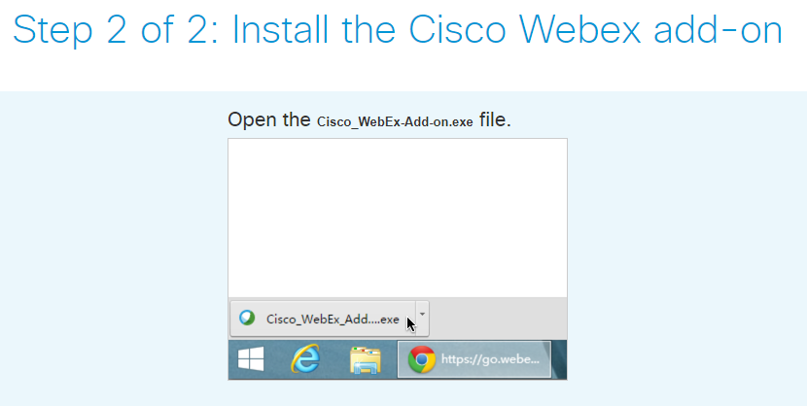

Firefox
Click on “Add Webex to Firefox” | 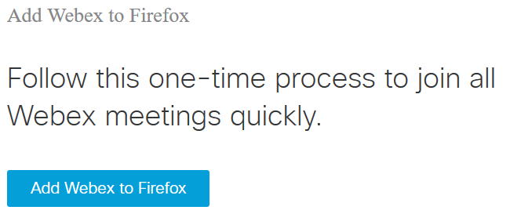
Click on “Continue to installation” | 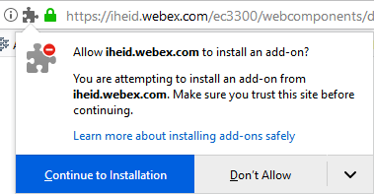
Click on “Add” | 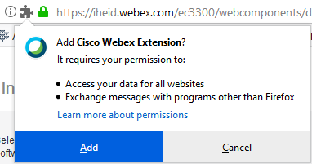
You can authorise the extension to open in private windows | 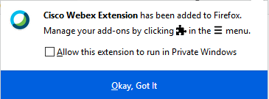
The final step is to download “Cisco_WebEx_Add-on.exe” (or .dmg if you are using a Mac). | 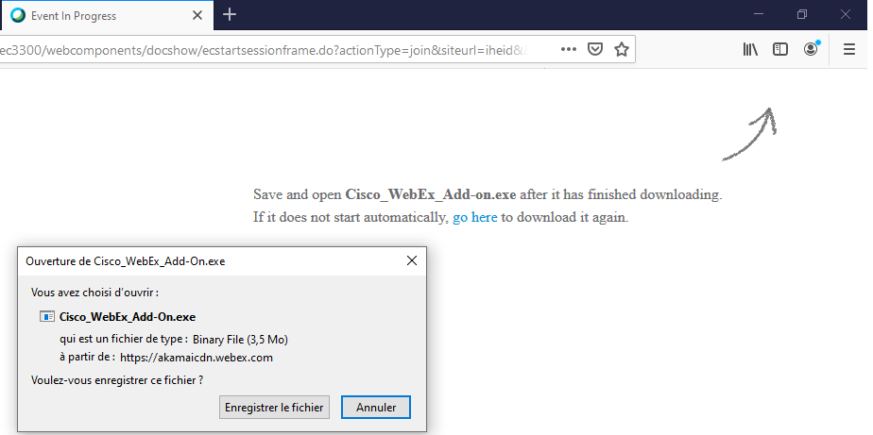

Safari

Click on “Download” | 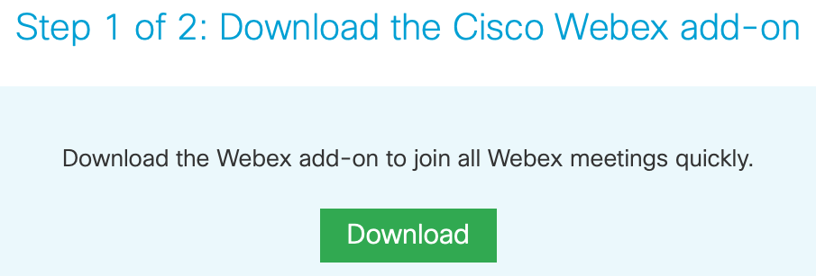
Click on “Allow” | 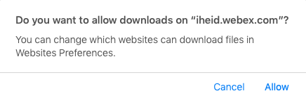
Open the “Cisco_WebEx_Add-on.dmg” file.  Double click on “Install Cisco_WebEx_Add-on”  The “preferences system” window will then appear, please select “Webex Meetings” as the final step. | 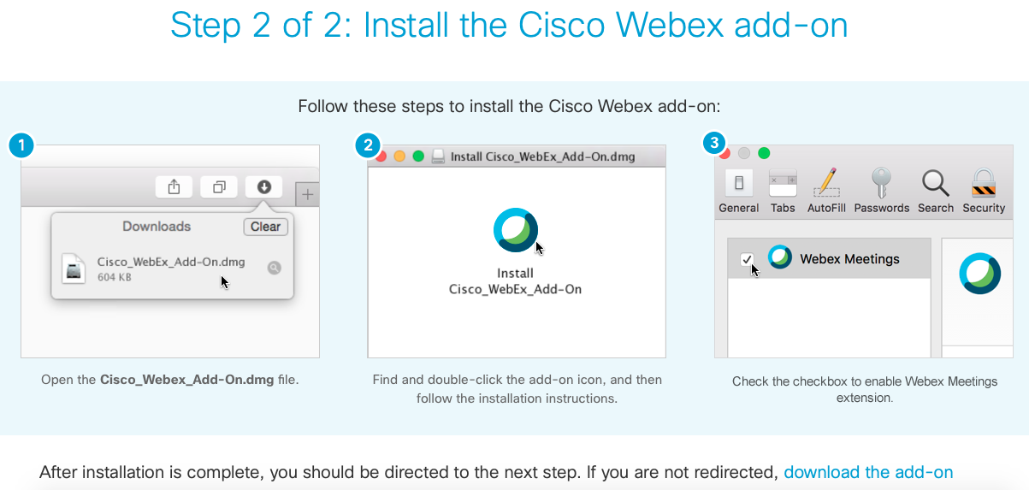

Audio
Before you join an event, please ensure that “Use computer for audio” is selected (as shown in the image below). By doing so, your microphone will be automatically muted, and your camera will be disabled (which is what is supposed to happen).

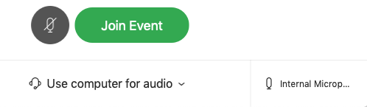

Asking questions
Follow these steps to ask questions during the Q&A session

- Click on the icon from your command bar in the bottom middle

- Type your question in the panel on the right side
- Select “Host” (as this will allow the moderator to see your question)
- Press Enter

Changing view
You can switch between video layouts during the session using the follow menu which you will find in the top right corner of you screen.

