Curriculum Vitae (post-2010)
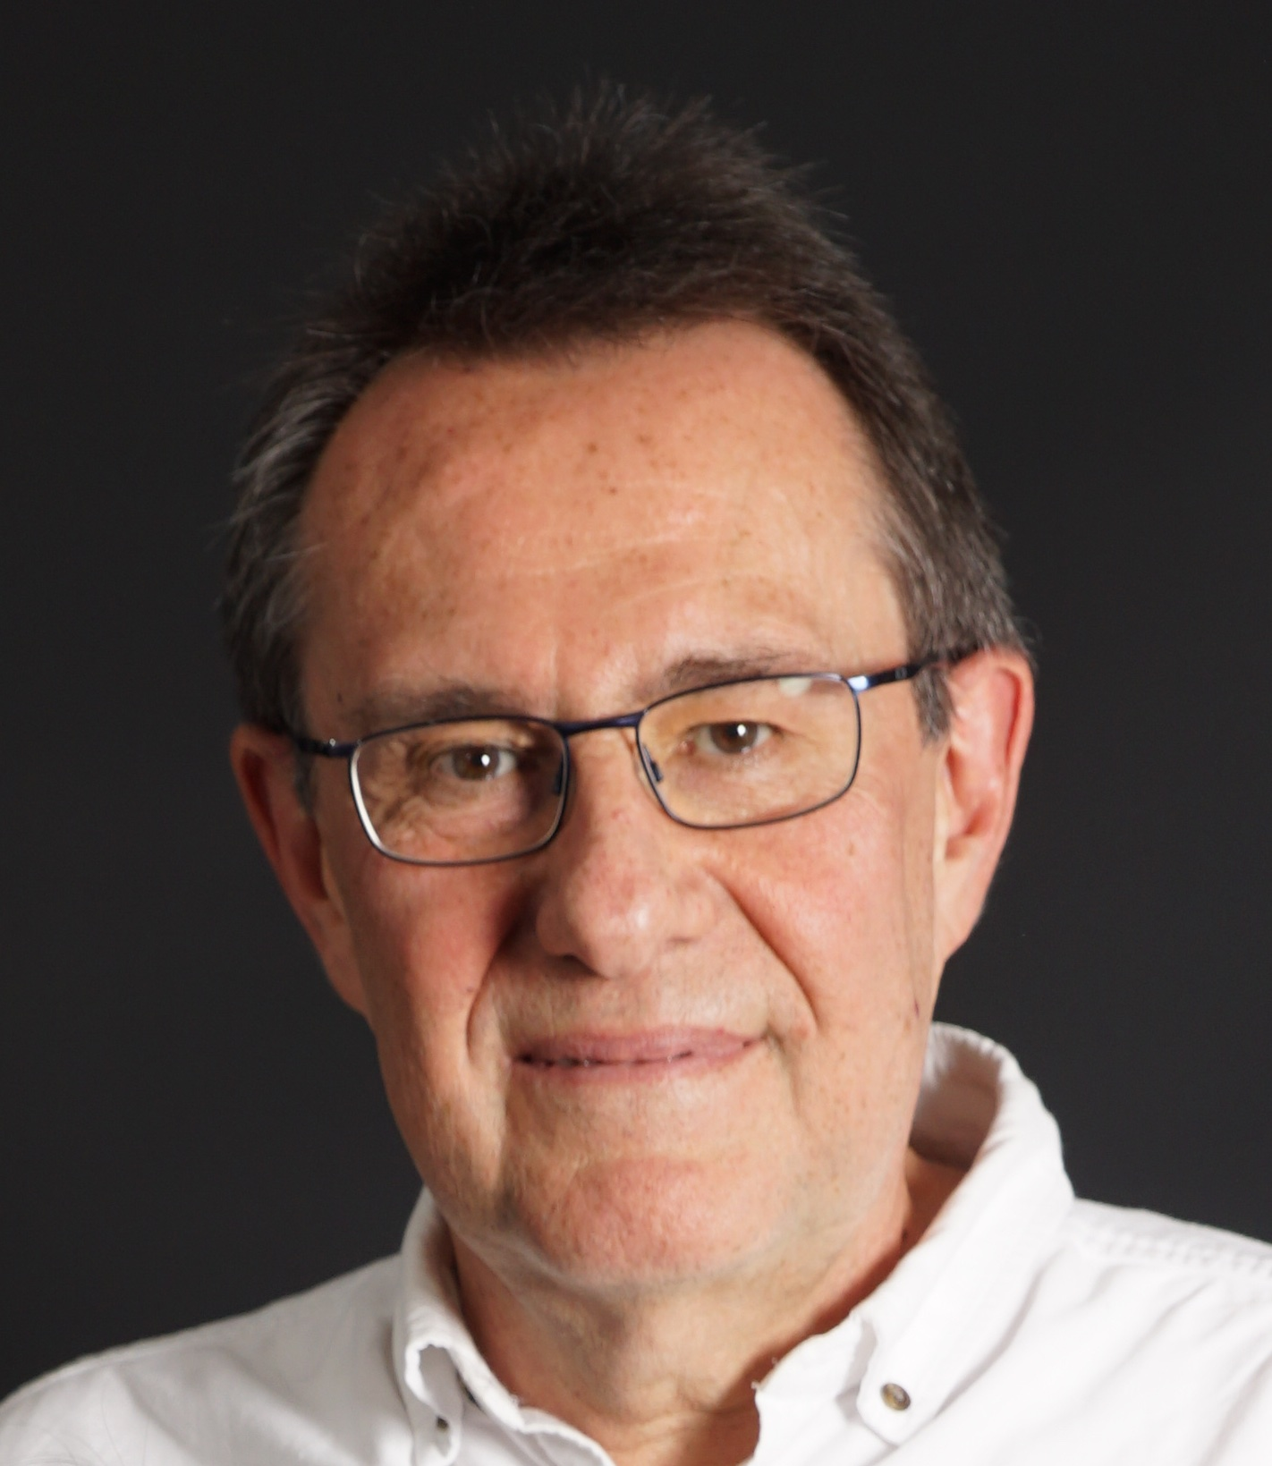
Name HUFTY, Marc
Title and address Professor (professeur titulaire)
Graduate Institute of International and Development Studies IHEID
Chemin Eugène-Rigot 2, CH-1211, Geneva 21, Switzerland
E-Mail marc.hufty@graduateinstitute.ch
Personal address 15, rue de la Tambourine, CH-1227 Carouge, Switzerland.
Tel.: +41 (0) 79 702 8183
Degrees
1996 PhD in political science (International History and Politics), Graduate Institute of International Studies (IUHEI), University of Geneva, Switzerland. Under the direction of Prof. Gilbert Etienne
Other positions
2017/… Senior lecturer (chargé de cours), Institut des sciences de l'environnement (ISE), Université de Genève, Cours « Gouvernance globale: biodiversité ».
2014 Visiting scholar, Institute for Behavioral Science, University of Colorado in Boulder, Fall.
Publications
Published

Reviewed Papers in journals
Lorca M, Escosteguy M, Köppel J, Hufty M, Scoville-Simonds M. 2022. Mining Indigenous Territories: Consensus, Dissent and Tensions in the Atacama Salt Flat. The Extractive Industries and Society. https://doi.org/10.1016/j.exis.2022.101047.
Scoville-Simonds, M., Jamali, A., Hufty, M. 2020. The Hazards of Mainstreaming: Climate change adaptation politics in three dimensions. World Development 125, 104683 doi.org/10.1016/j.worlddev.2019.104683
Ruysschaert, D., Hufty, M. 2018. Building an effective coalition to improve forest policy: Lessons from the coastal Tripa peat swamp rainforest, Sumatra, Indonesia. Land Use Policy. doi.org/10.1016/j.landusepol.2018.04.034
Lorca, M, Hufty, M. 2017. Gran Minería y Territorio. Usos Políticos del Patrimonio en el Huasco Alto, Región de Atacama, Chile, Intersecciones en Antropología, 18: 31-42.
Díaz-Castro L, Arredondo A, Pelcastre-Villafuerte BE, Hufty M. Gobernanza y salud mental: aportes para su abordaje en materia de políticas públicas. Rev Saude Publica. 2017; 51:4. DOI:10.1590/S1518-8787.2017051006991
Schulz, T., Hufty, M., Tschopp, M. 2017. Small and Smart: The role of Switzerland in the Cartagena and Nagoya Protocols negotiations, International Environmental Agreements. DOI 10.1007/s10784-016-9334-9
Díaz-Castro, L., Arredondo, A., Pelcastre-Villafuertec, B.E., Hufty, M. 2016. Indicadores de gobernanza en políticas y programas de salud mental en México: una perspectiva de actores clave. Gaceta Sanitaria. http://dx.doi.org/10.1016/j.gaceta.2016.08.001
Larsen, P., Hufty, M., Tran, C. et Gagnon, S. 2016. Commerce des espèces sauvages menacées : les paradoxes de l’État vietnamien. VertigO 16(1), mai 2016 [en ligne] URL : http://vertigo.revues.org/17097. DOI : 10.4000/vertigo.17097
Hufty, M. 2016. La gouvernance : polysémique, banale et neutre ? Studia Europaea 61 (1): 103-134.
Seghezzo, L., Volante, J.N., Paruelo, J., Somma, D.J., Buliubasich, E.C., Rodriguez, H., Gagnon, S., Hufty, M. 2011. Native Forests and Agriculture in Salta (Argentina): Conflicting Visions of Development. Journal of Environment and Development 20 (3) 251–277.
Hufty, M. and Haakenstad, A. 2011. Reduced Emissions from Deforestation and Degradation: A Critical Review. Consilience: The Journal of Sustainable Development. Columbia University. 5 (1): 1-24.
Hufty, M. 2010. Gobernanza en Salud Pública: Hacia un Marco Analítico. Revista de Salud Pública. 12 (1) Febrero: 39-61.
Book Chapters
Escosteguy M, Ibarnegaray M, Diaz Paz W, Stern H, Clavijo A, Insaurralde C, Venencia C, Brannstrom C, Hufty M, Segghezzo L. 2022. Will electro-mobility encourage injustices? The case of lithium production in the Argentine Puna. In: Democratizing Energy: Imaginaries, Transitions, Risks. Nadesan M, Pasqualetti M, Keahey J (eds). Arizona State University.
Hufty, M., 2021. Indigenous and local people. In: Morin, J.-F. & Orsini, A. (eds). Essential concepts of Global Environmental Governance. 2d Ed. Earthscan/Routledge. ISBN 9780367418694
Hufty, M., 2014. Indigenous and local people. In: Morin, J.-F. & Orsini, A. (eds). Essential concepts of Global Environmental Governance. Earthscan/Routledge. Pp. 95-98. ISBN 9780415822466 /473 / 565
Hufty, M., Schulz, T., Tschopp, M. 2014. The Role of Small States: Switzerland. In Sebastian Oberthür and Kristin Rosendal (Eds.): Global Governance of Genetic Resources: Access and Benefit Sharing after the Nagoya Protocol. Earthscan/Routledge. Pp. 96-113. ISBN 9780415656252
Hufty, M. 2012. A political ecology of Latin American forests through time. In C. Auroi and A. Helg (eds). Latin America 1810-2010: Dreams and Legacy. London: Imperial College Press, pp. 241-268.
Hufty M. 2011. Governance: Exploring four approaches and their relevance to research. In: Wiesmann U., Hurni H., et al. editors. Research for Sustainable Development: Foundations, Experiences, and Perspectives. Bern: NCCR North-South / Geographica Bernensia: 165–183. ISBN 978-3-905835-31-1
Hufty M. 2011. Investigating policy processes: The Governance Analytical Framework (GAF). In: Wiesmann, U., Hurni, H., et al. editors. Research for Sustainable Development: Foundations, Experiences, and Perspectives. Bern: NCCR North-South / Geographica Bernensia: 403–424.
Teachings

Regular teachings, Graduate Institute of International and Development Studies
2022/- An Introduction to the Analysis of International Environmental Problems (MINT258) with T. Swanson
2022/- Extractivism (MINT 255) with F. Calvão
2017/22 Conservation and Sustainable Development (MINT100) with T. Swanson and S. Hecht
2015/22 Social Movements and the Environment (MINT049)
2014/- Political Ecology (MINT005)
2015/- Biodiversité: entre science et politique (MINT039)
2010/18 Amérique latine: une histoire environnementale (HI097)
Other teachings and positions held
Institut des sciences de l’environnement (UNIGE), Boulder U. (Col), Tufts Fletcher School (MA), U. of Antananarivo (Madagascar), SHSA Zollikofen (CH), IUED, Laval U. (Canada), DPP-Desco (Peru), CABIR (Azerbaijan), San Antonio Abad Cusco (Peru), Lubumbashi (Congo), I. Juan Lazarte (Rosario, Argentina), U. de Belgrano (Argentina), Agruco (Bolivia), UBA (Argentina), Arcis (Santiago de Chile), U. Salta (Argentina)
Research activities
1. Research Projects (financed)
2022 Applicant. Lithium negotiations between South America and Europe: Towards a network and research agenda for a sustainable and just energy transition, With Diego Silva. Research Partnership Grants Bilateral research cooperation with the Latin American Region 2021-2024, University of StGallen, CHF 21’360
2021/23 Applicant. Green Dealings: Negotiating lithium between South America and Europe for batteries that fuel a just energy transition, SNIS. 8 partner researchers and 9 institutional partner organizations, CHF 266’000
2017/22 Applicant. The global political ecology of lithium (LITHIUM), SNF Section 1, with F. Calvão. Partners: Universidad Nacional de Salta Argentina, Universidad de Antofagasta Chile, CIDES San Andrés Bolivia. Budget: 569'322 CHF
2. Closed Research Projects (financed)
2012/16 Applicant. "Cultural Negotiations: Asymmetries in the TransArea". Under the coordination of prof. Y. Sánchez (UniSG). Partners: Corinne Pernet, UniSG; Aline Helg, History, UniGE; Stephan Rist, Geography, UniBE. Submitted to the Swiss National Fund for Scientific Research (ProDoc Programme). Budget: 535'548 CHF
2011/15 Applicant. "The Dynamics of Transcultural Management and Governance in Latin America". Doctoral School on Latin America, Training Module. Under the coordination of prof. Y. Sánchez (UNISG). Partners: University of St. Gallen, University of Geneva, IHEID. Financed by the Swiss National Fund for Scientific Research (ProDoc Programme). Budget: 451’000 CHF
2011/15 Main Applicant. "Transcultural Governance of the Environment in Latin America (TransGELA)". Research Module. Partners: University of St. Gallen and CDE (Bern). Financed by the Swiss National Fund for Scientific Research (ProDoc Programme). Budget: 330’000 CHF
2011/14 Main Applicant. "Adapting to Adaptation (ADAPT2): Studying the influence of climate change adaptation discourses and policies on local governance processes". Partners: IBC, Peru; DEPM, Pakistan; C3EDM. Financed by the Swiss National Fund for Scientific Research. Budget: 405’000 CHF
2011/13 Main Applicant. "Can small players make a difference? A multilevel governance assessment of the Swiss contribution to the establishment of an international regime on biodiversity (SWIC-2)". Partners: WSL (Birmesdorf), American University (Washington) and UNEP (Geneva). Financed by the Education and Research Secretariat (COST). 163’660 CHF
2010/12 Main Applicant. "CGPESA - Communities, Governance and Payment for Ecosystem Services in Amazonia". Fellowship for Dr. Marc Brightman. Financed by the European Science Foundation, Marie-Curie Action: "Intra-European Fellowships for Career Development". 180,970 €
2009/10 Main Applicant. "The Swiss contribution to global environmental governance: An Historical Perspective on the Role Played by Switzerland in Biodiversity Conventions (SWIC-1)". Partners: WSL (Birmesdorf), American University (Washington) and UNEP (Geneva). Financed by UNO-Academia. 7’000 CHF
Organization of scientific meetings and conferences
Over 30 conferences organized, over 100 talks given
Other scientific activities
2019/- Member, scientific advisory board for the SNSF-funded project on energy industrialization and the politics of productive sovereignty in Bolivia (Mark Goodale UNIL).
2017/- Participation as a consultant to the Food and Agriculture Organization's Governance Unit redesign of their internal model for the analysis of governance and its application to water governance. Under the direction of Dr. Klaus Urban & Dubravka Bojic.
2016/- Member, Advisory Group for Research Evaluation, Pontífica Universidad Catòlica del Perú. Vice-Rectorado de Investigación.
2015 Member, recruitment commission, Maître de conférence en droit public, Faculté d’Administration et Echanges Internationaux, Université Paris-Est Créteil Val de Marne, France.
Expert for the European region, UNEP Global Environment Outlook 6.
Member, Review Committee, The 11th Biennial Conference of the European Society for Ecological Economics, University of Leeds, UK on 30 June - 3 July 2015.
Member of the Atalaya Expert Forum on Disasters and Adaptation, February 10-15, USAid - WMO - NOAA - University of Colorado (CCB-INSTAAR)
2014 Visiting Scholar, Institute for Behavioral Studies, University of Colorado in Boulder, September-December 2014.
Member, Scientific Committee, 1st international Congress of Biodiversity and Wetland, El-Tarf University, Algeria, 13-15 May 2014.
2014/… Member of the Board, Swiss Association for Latin American Studies
2013 Member of the Panel of Experts, Food Security and Land Use Change joint program of the Belmont Forum (International Group of Funding Agencies for Global Change Research) and FACCE-JPI (Initiative on Agriculture, Food Security and Climate Change). http://www.igfagcr.org/index.php/fs-and-luc
2013/15 Member of the Advisory Board, Project "Sustainable Soil Governance and Large-Scale Land Acquisitions Originating in Switzerland", CDE-UNIBE, World Trade Institute (WTI), Agroscope (SNF NRP 68).
2013/17 Member of IRD Expert Committee for Research and Training in the South (Direction des programmes de recherche et de la formation au Sud, Marseilles), http://www.ird.fr/
2013/20 Member of the Plenum, Swiss Biodiversity Forum, www.biodiversity.ch
2012/13 Member, scientific committee, Ecological Economics and Institutional Dynamics, 10th International conference of the European Society for Ecological Economics (Lille). esee2013.sciencesconf.org/
2011/… Member of the Board and senior researcher, Centre for International Environmental Studies, Graduate Institute. http://www.graduateinstitute.ch/cies
2011 Expert Group on EU REDD Policy, DG Clima, Brussels, 9-10 Nov. 2011.
2007/… Réseau de recherche sur la gouvernance REGIMEN (Comité exécutif)
Membership:
Association internationale de science politique (AISP); Association suisse des américanistes (ASA); International Studies Association (ISA) (Environment and Development Sections); Environmental Studies Association of Canada (ESAC); Mountain Research Initiative; Proclim; Society for Conservation Biology (SCB); REGIMEN (comité exécutif), Réseau GloGov (IVM Amsterdam); Association québécoise de science politique; Canadian Association of Political Science.
Reviewer for the following journals:
Sustainability; Norwegian Journal of Geography The European Journal of Development Research; Natures Sciences Sociétés; Etudes internationales; Economie rurale; Human Ecology; Politique et Société; Global Environmental Politics; International Review of Administrative Sciences; European Journal of Forest Research; Environment & Planning; Political Studies; Review of International Studies; Fédéralisme-Régionalisme; Madagascar Conservation and Development; Global Environmental Change; Sustainability; International Environmental Agreements: Politics Law and Economics; Environmental Science & Policy; Environmental Management
Expert for:
AERES (French Government's unit for the evaluation of university departments); Belmont Forum (multilateral initiative for research in sustainable development); IRD (French Institute for research in developing countries); Economic & Social Research Council (UK); Le Studium (Orléans - France); Agence Nationale de la Recherche (ANR - France); Zentrum für Internationale Landwirtschaft (ZIL, ETHZ, Switzerland); International Foundation for Science (Sweden); Conseil de recherches en sciences humaines du Canada (CRSH); Swiss National Fund for Scientific Research; Miembro, Directorio de Evaluadores Externos de la PUCP (Peru)
Supervision
5 postdocs, 16 PhDs, >200 master thesis
Outreach
Numerous papers or interviews in various medias: Le Temps, La Tribune de Genève, L’Hebdo, Radio suisse romande, Télévision suisse italienne, Télévision suisse romande, Radio France internationale, TV5, public conferences, etc.
MH / March 2022

